**Final Project Selection**

**Team:** Milky Way Solutions (MWS)

**Project Name:** *Ion Chamber Calibration Device (“CC” for Chamber Calibrator)*

**Project Client:** *Dr. Hans Sonke Jans – Cross Cancer Institute, Dept. of Medical Physics*

**Brief description of project:** Nuclear medicine offers imaging and treatment methods for cancer patients. Patient doses are measured using “Dose Calibrators,” but those must also be calibrated via standards laboratories. The CC would offer an alternative to standards laboratories, providing clinicians with real-time sample data, and facilitating the administration of safe, and precise dosages.

**Preliminary Approach:**

We have met with the client 2 times now, and he has a very strong understanding of the science accompanying the project, and the necessary engineering.

He has already developed a high level schematic of the project (see below), and purchased a 10 thousand dollar electrometer to supply the 400-500 Volts for the ion chamber, and measure currents in the picoamp range.

We are planning on using a raspberry pi as our internal controller, as we’ll need to consider several inputs, and program a touch screen (harder to manage with an Arduino). The DC Power Supply (see image below) will likely be purchased online. Some adjustments/additions may need to be made depending on the product purchased.

In order to test our project, we will likely need a reference picoamp current source (it would be expensive, and inefficient to test using an ion chamber each time). This would be quite challenging to build from scratch, but some alternatives include commercial products and equipment from Dr. Barlage’s lab.

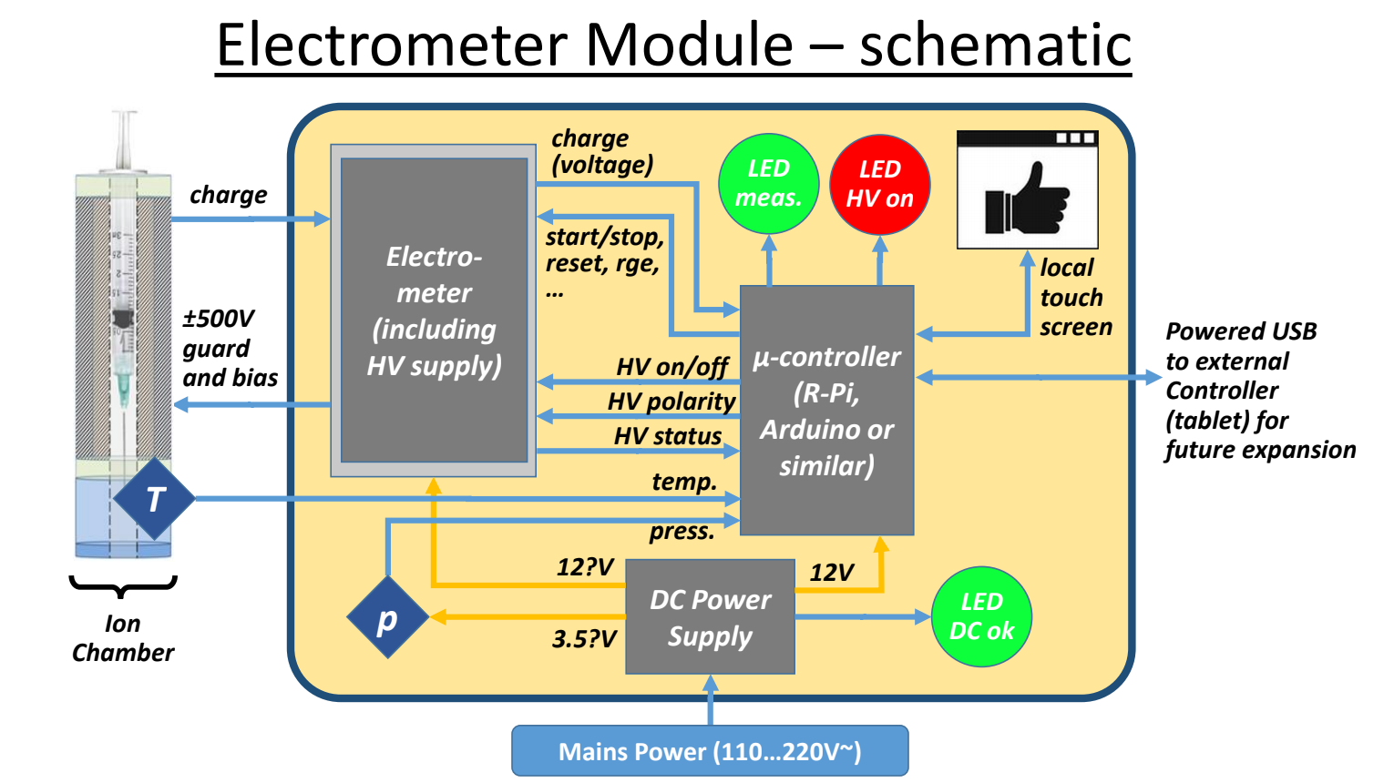

After discussions with TA and confirmations with any kind of client. Document with your team the final project selection.

Briefly discuss a preliminary approach to the problem. Formal solution will be due next week.

For some of your projects, the preliminary project selection may suffice as your final project selection.

This is just a confirmation of the project area that you intend to work on.